Azure DevOps Pipeline

Create Azure Container Registry (ACR)

Step 1: Create ACR
az acr create \
--resource-group <RG_NAME> \
--name <ACR_NAME> \
--sku Basic

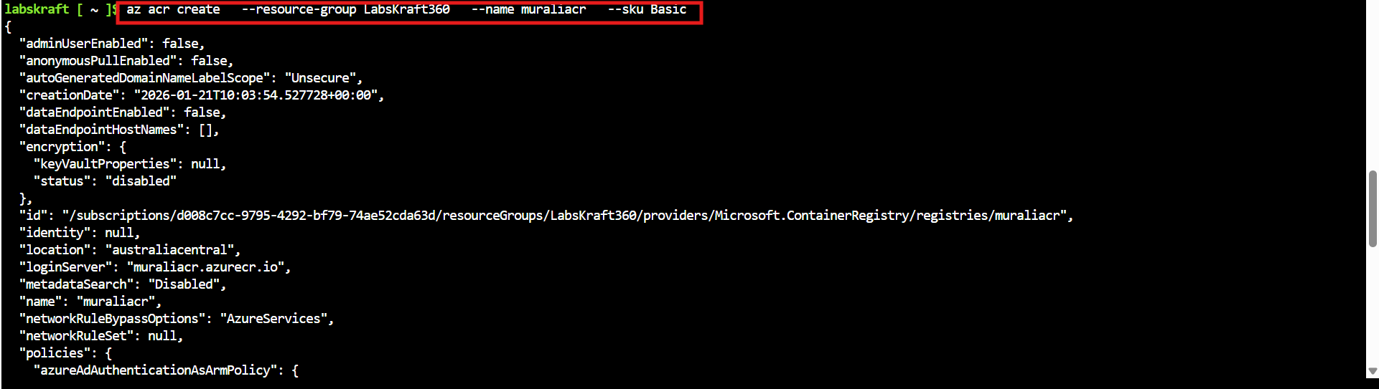

az acr list –output table

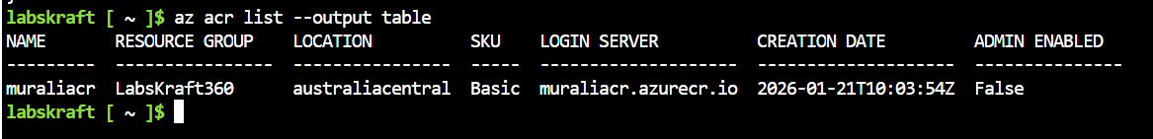

Attach ACR to AKS (IMPORTANT)
This allows AKS to pull images without secrets.
az aks update \
--resource-group <RG_NAME> \
--name <AKS_NAME> \
--attach-acr <ACR_NAME>
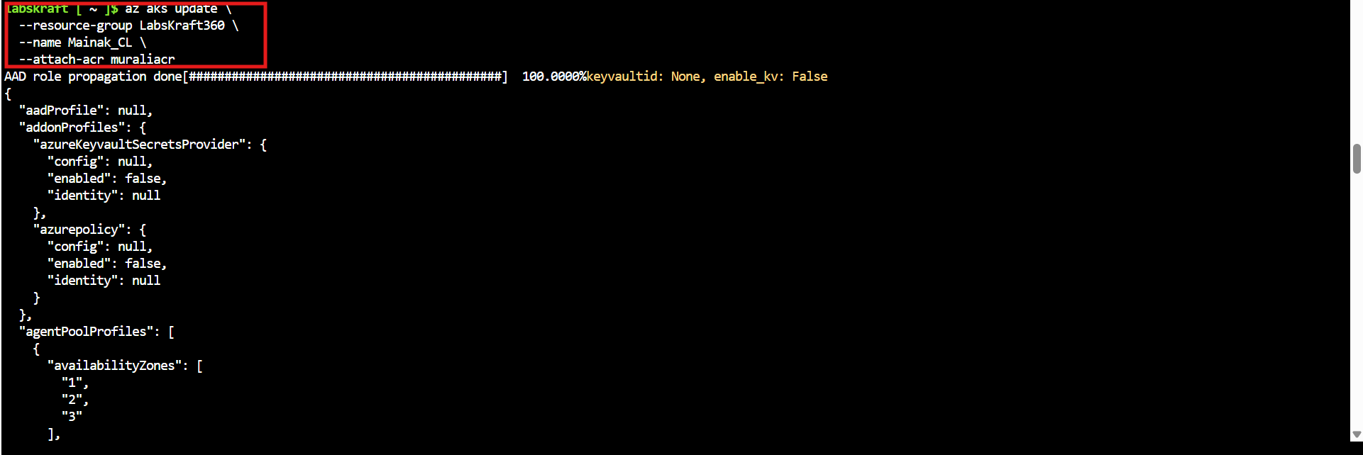
- Create a file called azure-devops.yaml file and paste below script
trigger:
- azure-argo-GA

variables:
imageName: fitness-app
acrLoginServer: fitnessacr123.azurecr.io
tag: $(Build.BuildId)

pool:
vmImage: ubuntu-latest

steps:
- checkout: self

- task: Docker@2
displayName: Build and Push Image
inputs:
command: buildAndPush
repository: $(imageName)
dockerfile: Dockerfile
containerRegistry: ACR-Service-Connection
tags: |
$(tag)

# Update Helm values.yaml
- script: |
sed -i "s/tag:.*/tag: \"$(tag)\"/" helm/fitness-app/values.yaml
git config user.email "devops@company.com"
git config user.name "azure-devops"
git add helm/fitness-app/values.yaml
git commit -m "Update image tag to $(tag)"
git push origin azure-argo-GA
displayName: Update Helm values

Create Required Service Connections (VERY IMPORTANT)
Your pipeline will FAIL without these.

1. Azure Resource Manager Service Connection
Used for:
- Azure authentication
- ACR access
Azure DevOps → Project Settings → Service Connections → New
Choose Azure Resource Manager

- Choose login mail id
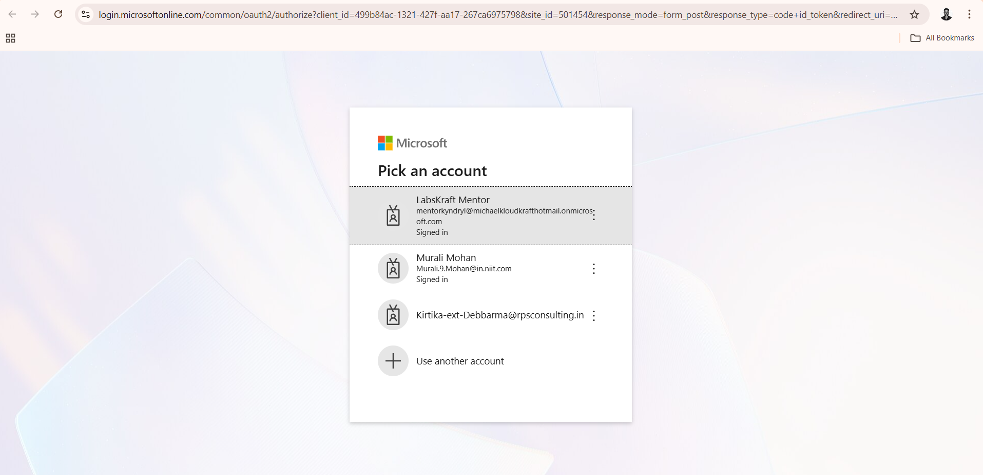

- Confirm following details and click on continue
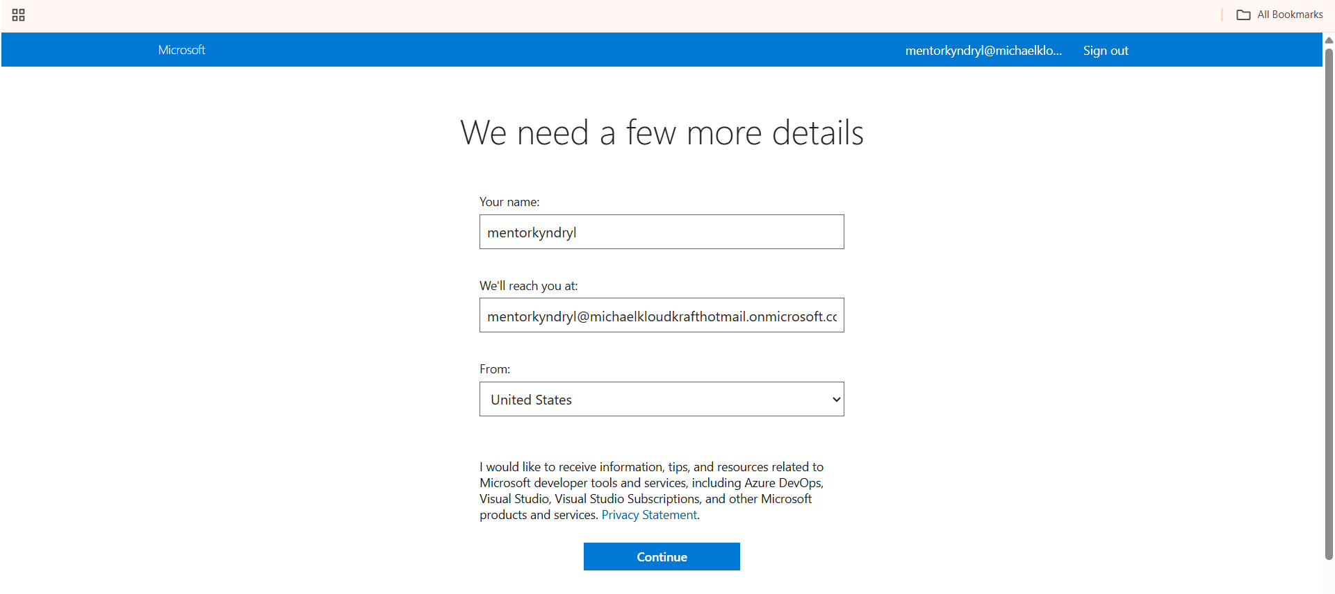

- Click on create org
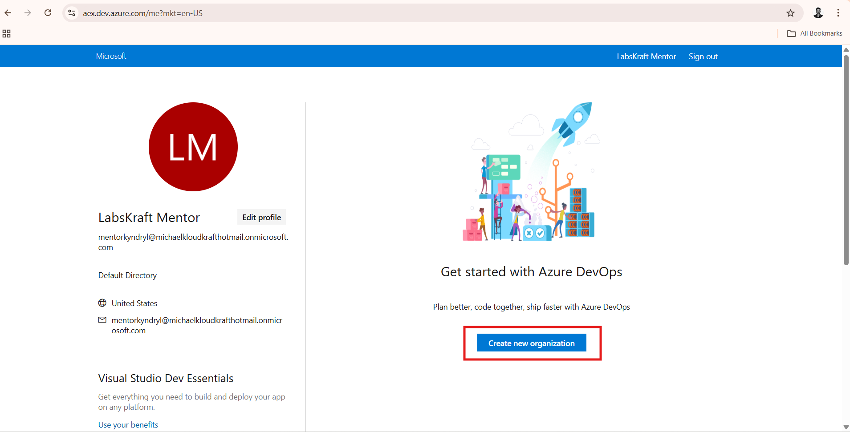

- Click on continue
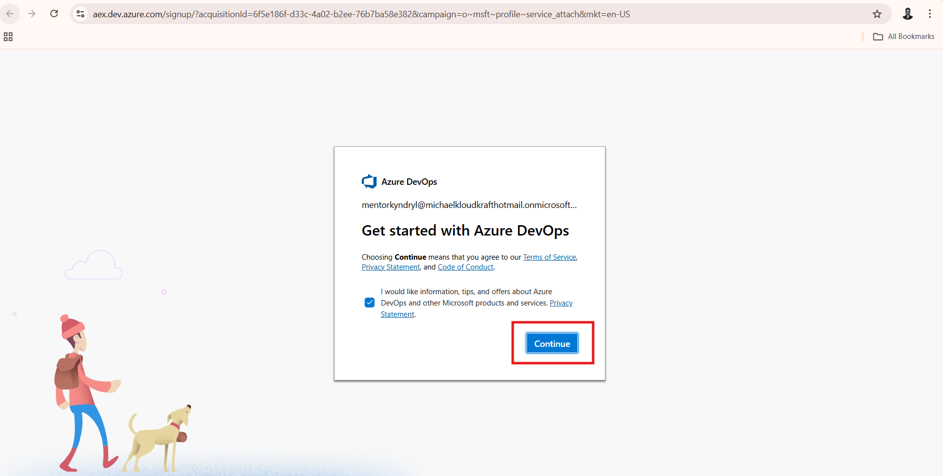

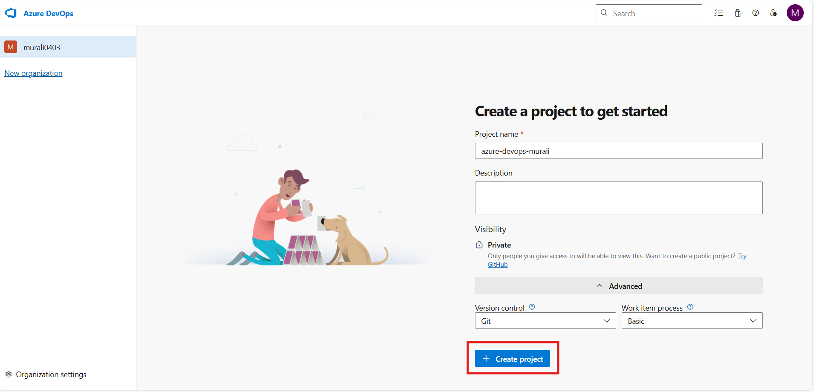

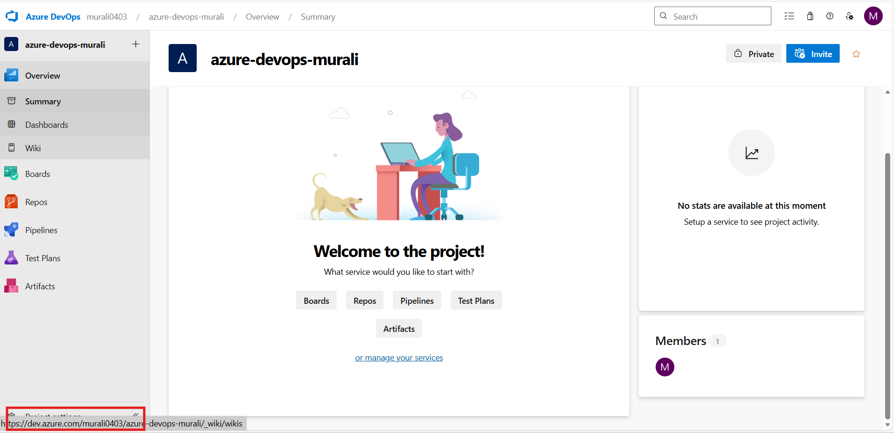

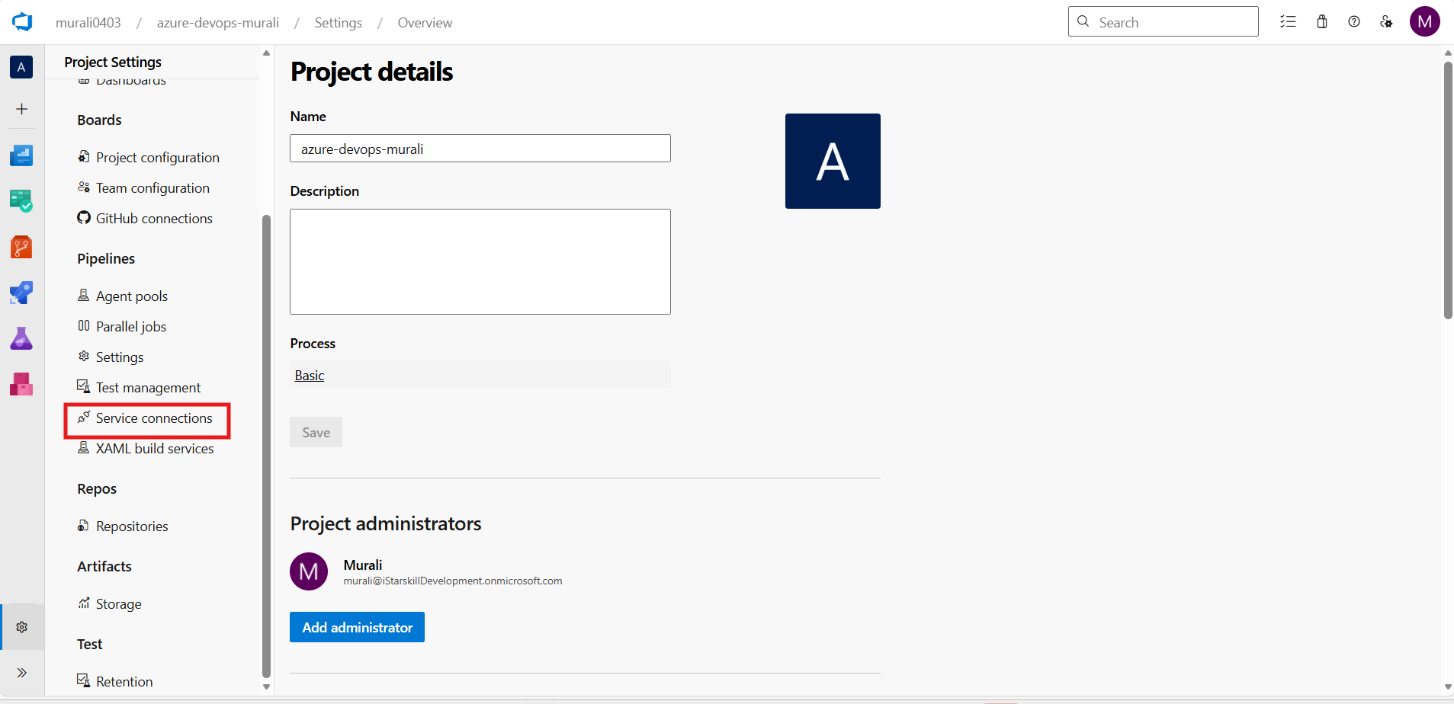


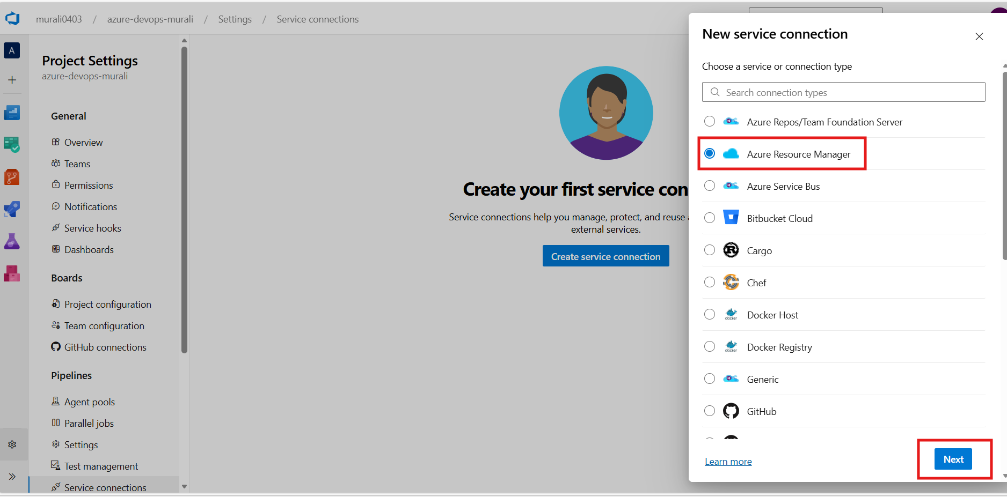

Subscription-based
Grant access to all pipelines

2. Docker Registry Service Connection (ACR)
Project Settings → Service Connections → New
Choose Docker Registry
- Registry type: Azure Container Registry
- Select your ACR
- Grant access to all pipelines

Update Pipeline YAML with Correct Service Connection Names
Example:
containerRegistry: ACR-Service-Connection
This must exactly match the name you created in Azure DevOps.

- Create a pipeline
